**IRevolution: A Data-Driven Exploration Of Apple's IPhone Impact In India**

Introduction:

Overview:

The introduction of the Apple iPhone marked a significant turning point in the world of technology and consumer electronics. It not only transformed the way people communicate but also had a profound impact on economies and societies worldwide. This project aims to analyze and visualize the far-reaching impact of the Apple iPhone on the Indian market, economy, and society using data-driven insights through Tableau.

**PURPOSE:**

The purpose of the "Apple iPhone Impact on India" project on Tableau is multifaceted and can include the following objectives:

Historical Analysis: To chronicle the introduction of Apple iPhones in India and their evolving features over time.

Economic Insights: To assess the economic impact, including contributions to India's GDP, trade balance, and employment generation in the technology and related sectors.

Market Analysis: To understand the growth of iPhone sales in India, market share, and competition with other smartphone brands.

Societal Impact: To explore how iPhones have influenced consumer behavior, communication patterns, and technological literacy in Indian society.

|  |
| --- |
|  |

**PROBLEM STATEMENT & DESIGN THINKING**

**PROBLEM STATEMENT:** The widespread adoption of Apple iPhones in India has transformed the country's technology landscape, but there is a need to comprehensively understand and visualize the multifaceted impact of this revolution on the economy, society, and culture. This project seeks to address this gap by analyzing and visualizing the data to provide insights into how iPhones have shaped India's tech ecosystem, consumer behavior, and economic dynamics.

**DESIGN THINKING:**

1.Empathize:Understand the needs and concerns of various stakeholders, including consumers, businesses, policymakers, and researchers.Conduct surveys, interviews, and gather feedback to empathize with the target audience

2. Define:Clearly define the scope of the project, its objectives, and the key questions to be answered.Identify the main challenges and opportunities related to studying the impact of iPhones in India.

3. Ideate:Brainstorm ideas for data sources, variables, and metrics that will help in understanding the impact.Explore innovative ways to visualize data to make it accessible and engaging.

4. Prototype:Create initial data visualizations and dashboards using Tableau.Develop a prototype of the project to gather feedback and refine the design.

5. Test:Share the prototype with potential users and stakeholders.Gather feedback to make necessary improvements and ensure the project aligns with their needs

.6. Implement:Utilize the feedback to finalize the project design and data visualizations.Implement the full project using Tableau to analyze and present the impact of iPhones in India.

7. Evaluate:Continuously assess the project

|  |
| --- |
|  |

**EMPATHY MAP:**

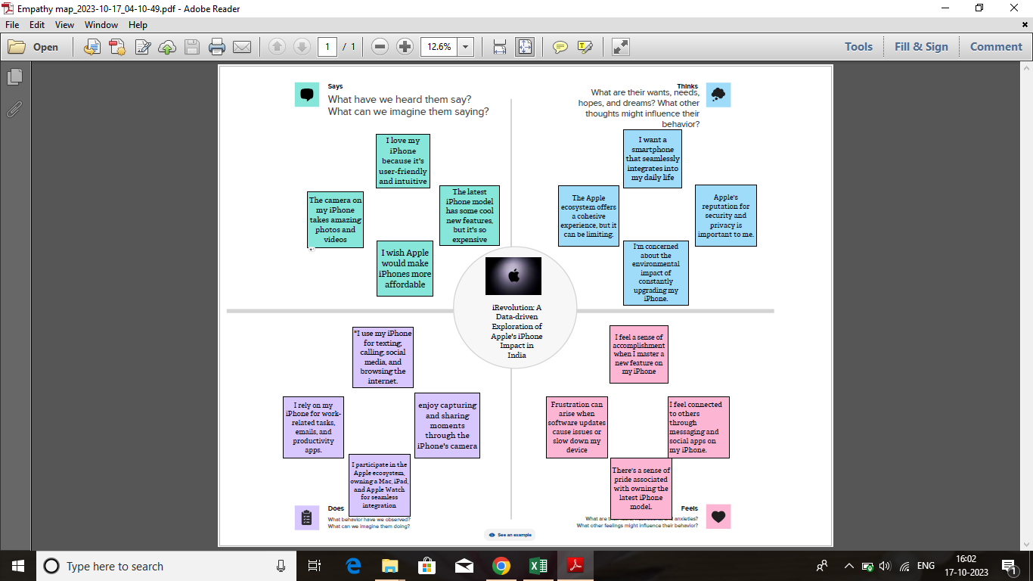

**BRAINSTORMING MAP:**

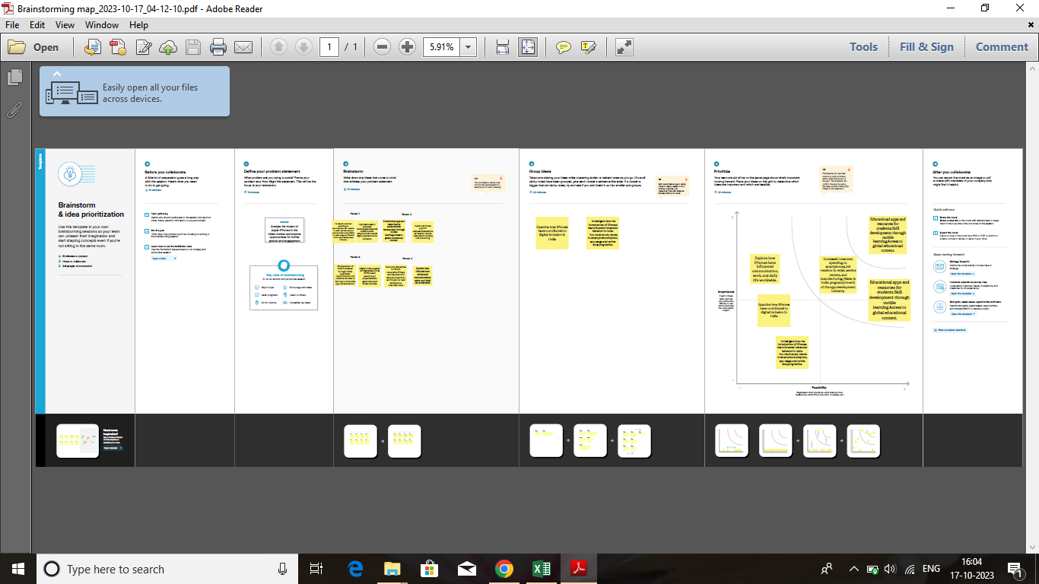

**Advantages:**

Economic Growth: The presence of Apple in India has led to the creation of jobs in manufacturing, retail, and the app development ecosystem, contributing to economic growth.

Technology Adoption: Apple's products have driven technology adoption in India, encouraging consumers to embrace smartphones and their ecosystem.

Quality and Innovation: Apple's focus on quality and innovation has set standards in the industry, influencing other brands to improve their offerings.

App Development: The App Store has provided opportunities for Indian developers, resulting in a thriving app development community.

**Disadvantages:**

Cost: Apple products are relatively expensive, making them less affordable for a significant portion of the Indian population.

Price Discrimination: In some cases, Apple's pricing strategies can result in higher prices for Indian consumers compared to other markets.

Limited Market Share: While Apple has a presence in India, it has a relatively small market share compared to other smartphone brands, limiting its overall impact.Limited

Manufacturing: While Apple has started manufacturing some iPhone models in India, a significant portion of its products is still imported, which can affect local manufacturing and job creation

|  |
| --- |
|  |

**APPLICATIONS:**

Economic Growth: Apple's presence in India has led to the growth of the smartphone manufacturing industry, contributing to the "Make in India" initiative and generating employment opportunities.

Digital Transformation: iPhones have played a pivotal role in driving digital transformation in India. They are used in various sectors like education, healthcare, e-commerce, and finance to access information, services, and apps

.App Development: The App Store has opened up opportunities for Indian app developers, resulting in the creation of a wide range of mobile applications that cater to both Indian and global markets.

Education: iPhones and iPads are used in education, from primary schools to universities. They offer educational apps and digital content, enabling e-learning and interactive teaching methods.

Healthcare: iPhones are used in healthcare for patient monitoring, telemedicine, and the development of healthcare apps that track health and fitness.

Entertainment: India's entertainment industry, including music, movies, and gaming, leverages iPhones for content consumption and distribution.

E-commerce: iPhones have transformed the way people shop in India, with numerous e-commerce apps and mobile wallets facilitating online transactions.

Startups: The thriving app ecosystem has provided a platform for Indian startups to develop innovative solutions and disrupt various industries.

Innovation and Design: Apple's emphasis on design and user experience has influenced product design and user interface trends in the Indian tech industry.

Market Competition: The presence of Apple has driven other smartphone manufacturers to improve their products and services, leading to more choices for consumers.

|  |  |
| --- | --- |
|  |  |

**CONCLUSION:**

This Tableau project aims to provide a comprehensive analysis of the transformative influence of the Apple iPhone in India. By visualizing the data, we can gain a deeper understanding of the societal, economic, and technological shifts that this iconic device has brought about.

**FUTURE SCOPE:**

Economic Growth: Apple's presence in India has led to the growth of the smartphone manufacturing industry, contributing to the "Make in India" initiative and generating employment opportunities

.Digital Transformation: iPhones have played a pivotal role in driving digital transformation in India. They are used in various sectors like education, healthcare, e-commerce, and finance to access information, services, and apps

.App Development: The App Store has opened up opportunities for Indian app developers, resulting in the creation of a wide range of mobile applications that cater to both Indian and global markets.

Education: iPhones and iPads are used in education, from primary schools to universities. They offer educational apps and digital content, enabling e-learning and interactive teaching methods.

Healthcare: iPhones are used in healthcare for patient monitoring, telemedicine, and the development of healthcare apps that track health and fitness.Entertainment: India's entertainment industry, including music, movies, and gaming, leverages iPhones for content consumption and distribution.

E-commerce: iPhones have transformed the way people shop in India, with numerous e-commerce apps and mobile wallets facilitating online transactions.Startups: The thriving app ecosystem has provided a platform for Indian startups to develop innovative solutions and disrupt various industries.

Innovation and Design: Apple's emphasis on design and user experience has influenced product design and user interface trends in the Indian tech industry.

Market Competition: The presence of Apple has driven other smartphone manufacturers to improve their products and services, leading to more choices for consumers.

|  |  |
| --- | --- |
|  |  |

**RESULT:**

